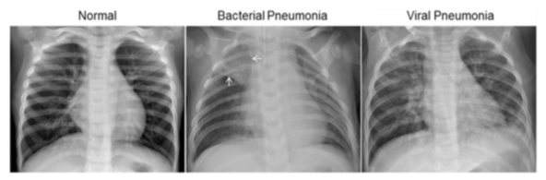
Identifying Pneumonia via Chest X-Ray Images with Convolutional Neural Networks
- Introduction

In the years following the Covid-19 epidemic, concerns about adequate hospital staffing have risen due to staff burnout, strikes, and high-pressure working conditions. One of the ways to help support the medical experts is by reducing their workload. This can be done by automating routine tasks such as diagnoses so that medical professionals can instead spend their finite time focusing on providing patients with quality care.
In this paper, we look at how to train a model to diagnose pneumonia. Pneumonia is a common illness that affects millions of Americans, leading to 55,000 deaths in severe cases. It is noted for being the most common cause of death in developing countries. For that reason, investing in technology that improves hospital working conditions would significantly impact the work and lives of both radiologists and patients.
One of the ways in which this investment can come to fruition is using machine learning. Machine learning arrives hand-in-hand with automating tasks because it is most often used to take over the drudgery of mundane tasks that humans have no choice in doing. In this paper, we aim for a machine model to take over the task of labeling chest x-ray images with either being normal or being pneumonia-positive.

- Data and Related Work

2a. Sourcing Data
The dataset contains 5,863 X-Ray JPEG images of lungs from patients from the Guangzhou Women and Children’s Medical Center in Guangzhou taken during routine clinical care. The data has been divided into three folders: one for training, another for validating, and the last for testing. Each folder contains subfolders with the labels ‘NORMAL’ or ‘PNEUMONIA’ indicating the state of the lungs.
Examples of the image data the model used to learn. A normal set of lungs will be noticeably clearer. Infected lungs with bacterial pneumonia will feature a focal lobar consolidation (indicated by the white arrows.) Viral pneumonia will be more evenly spread throughout both lungs.

To feed accurate data to the model, all radiographs were screened for quality control by removing unusable data based on being low quality or unreadable. Two expert radiologists then went through all the images and manually labeled each image. Finally, a third radiologist also checked the evaluation set.
To feed accurate data to the model, all radiographs were screened for quality control by removing unusable data based on being low quality or unreadable. Two expert radiologists then went through all the images and manually labeled each image. Finally, a third radiologist also checked the evaluation set.

2b. Related Work
A study that has performed similar work regarding training a model by using biomedical imaging is that done by the team which produced the following: “Identifying Medical Diagnoses and Treatable Diseases by Image-Based Deep Learning.” This team uses the same Chest X-Ray dataset to delve deeper into whether a machine model is capable of differentiating between pneumonia causes by bacterial infection vs viral. They also employ other datasets relevant to biomedical imaging in their work.
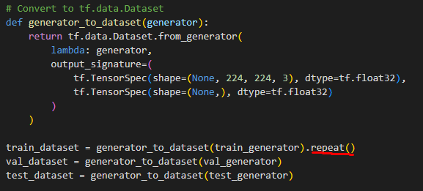
Rather than solely relying on convolutional neural networks as this paper does, the team makes up for the shortcomings of the shared dataset by utilizing a tool known as transfer learning. Transfer learning works essentially by recycling a trained model that has learned one dataset to learn another. In this way, the team improves their model by usage of greater resources i.e. data.

- Methodology

Because the dataset consists purely of images, I decided to use a convolutional neural network as the experiment’s deep learning model. This approach requires dividing the data into three categories (training, validating, and testing), which the data source has already provided. The data is set to be pre-processed by augmentation and normalization in order to improve the model’s ability to predict labels based on images outside of the dataset. The data is then loaded in and further improved for runtime performance’s sake.
The convolutional neural network model then is built using TensorFlow and Keras. Our convolutional network uses ReLU activation functions in the hidden layers, and a softmax activation for the output layer on the basis of having two classes (normal vs pneumonia). After the model is compiled, we can now train it using the processed data from the previous section. An evaluation section has been added for noting the accuracy of our testing data and which determines how reliable our model is. An output section that illustrates how the model predicts data ends the experiment.

- Experimental

To overcome the limitations of the training data available, the tf.data.Dataset converts the data from the generator functions to a dataset that can be looped. During the training of the model, I found that an error consistently arose where the model ran out of training data, so I created a loop to avoid this error.

The .repeat() function is unable to be applied to the train_generator function itself, which led to this code being added

Afterwards, I applied a prefetch method to address a runtime inconvenience where evaluating the testing data was taking an hour per epoch. The prefetch method is used to address and improve performance issues. Later, this inconvenience was circumvented by adjusting Google Colab to run on a GPU instead of a CPU.
The code for the neural network takes advantage of TensorFlow Keras’ API by using a Sequential model where the model can be built in a straightforward manner, one layer at a time. This is where the convolutional aspect of the model comes into play as five convolutional layers are added here to apply filters to the input images so that distinguishing features can be detected. Three max pooling layers are also added to further extract those features. The convolutional neural network adds the fully connected layers with ReLU activation functions, and the model is completed by a softmax activation layer as the output.

- Measurement

Because I kept running out of training data, my code for training the data included a len() function so as to keep running: 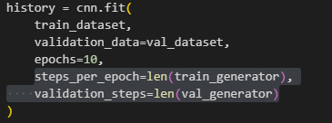
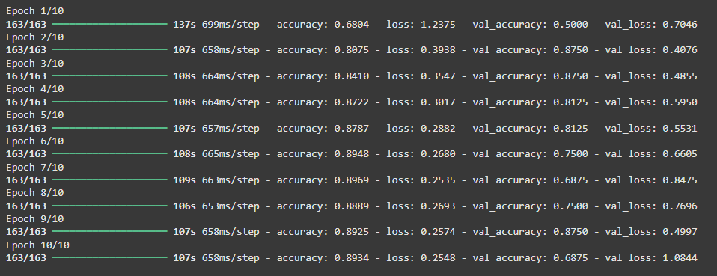
This code was used to measure the accuracy of both the training and validation data sets:

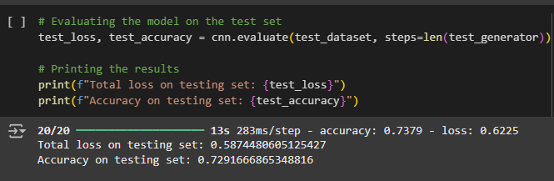
Similarly, evaluating the model itself uses a len() function to avoid running out of data and outputs the accuracy of the testing dataset to determine how reliable the model is:
The experiment concludes with getting a random batch of three images from the dataset, analyzing them, and outputting the images with a label of 1 or 0 depending on whether the image is normal (1) or not (0).

- Result Analysis, Intuitions, and Comparison

In the evaluation of my testing set, the output came out to the following: 0.7291666865348816. Despite adjusting the epochs for higher runs (going from 5 epochs to 10), the testing accuracy actually decreased in contrast to the training accuracy. Furthermore, the validation accuracy fluctuated from epoch to epoch, leading me to believe that the weakness of the dataset (small data available for validation), was making itself known.
Based off the output images, I would guess that the model is predicting accurately as I can see that the images with predicted pneumonia are cloudier than the images predicted to be normal. However, due to my lack of radiology expertise, I cannot depend on being able to verify the images myself.
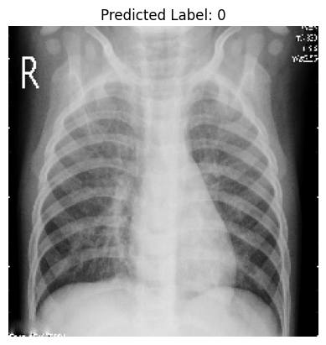
Example of an image being predicted to have pneumonia (predicted label: 0).

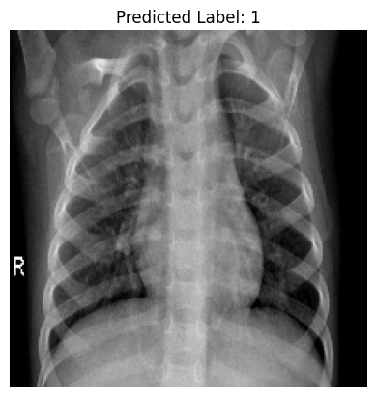
Example of an image being predicted to be normal (predicted label: 1).

- Conclusion

Because the validation set was so immensely limited by the 16 images available, I would be highly hesitant to use the model despite the evaluation accuracy coming out to around 73%. Aside from the accuracy rate being below general practice standards of 90%, the validation data was outnumbered by the testing data at a ratio of 16:624. This is almost a 1:40 ratio when the ratios should be either equal or higher in favor of validation data.
Another setback I encountered revolved around using Google Colab. I commonly encountered the warning that I was about to run out of free daily runtime resources, and this limited my ability to edit the code based on how often I could run it.

- Contribution
I, Crystal Diaz, certify that I worked solo on both the report and the code for the model, and my GitHub can be accessed using the following link:
https://github.com/iochuu/CECS-456

